Module Assembly - TC Cockpit Project Milestones Service Integration and Testing Deployment Guide

Revision History
Author | Revision Number | Date
TCSASSEMBER | 1.0 | 02/09/2012

Deployment Instructions 3
1. Organization of Submission 3
2. Application Setup 3
2.1 Ant .Properties File 3
2.2 Build Scripts Setup 3
3. Database Setup 4
4. Deployment Instructions 4
5. Starting 4
6. Verification 4
7. Resource Contact List 5

Deployment Instructions

Organization of Submission

The submission follows directory structure provided below:

doc
Contains the Deployment Guide Document of this assembly.

direct
Contains sources and static files for Direct web application. This directory replicates the application development distribution structure and includes only updated and new files.

db_scripts
Contains the updated files for https://coder.topcoder.com/internal/database/scripts/trunk

test_files
Contains the sql to add new tables for the milestone service : schema_setup.sql
Contains the sql to add copilot test data to testing milestone service : insert_copilots.sql
topcoder_cockpit_project_milestone_services
Contains changed codes of TopCoder Cockpit Project Milesones Services.

Application Setup

The application is expected to be deployed to the following environment:

JRE 1.5
JBoss 4.2.3.GA
Informix DS 11.5

Ant .Properties File

No .properties files are modified.

Build Scripts Setup

The ANT build script for Direct application (build.xml) provides the following targets which are to be used:

- switch-and-checkout – checkout or switch to the defined source code branches for all components defined in subprojects.xml
- dist-backend – rebuilt all the components from the source code.
- first_deploy – must be the first task to execute from command line. It will copy all dependencies to your local JBoss folder.
- deploy – should be the main task to execute from command line. It will build and deploy WAR file.
- deploy-static-files – deploys the static files to JBOSS.
- deploy-apache-static – deploys the static files to apache server on VM.

Please refer here for more information:
http://www.topcoder.com/wiki/display/docs/TC+Direct+Setup+Guide

Database Setup

- Run the test_files/schema_setup.sql to insert new tables for project milestone.
- If deploying on local environment, you can merge the files in directory db_scripts to https://coder.topcoder.com/internal/database/scripts/trunk and resetup the database.

Deployment Instructions

Run new_metadata_key.sql against the database to insert the new project metadata key : project privacy flag

This section provides the instructions in Production environment.

- Merge the codes and build scripts in direct directory to the target svn trunk.
- Run ‘ant switch-and-checkout’ to check out the TopCoder Cockpit Project Milestone Services which has been added into subprojects.xml
- Merge the codes and build scripts in topcoder_cockpit_project_milestone_services directory into topcoder_cockpit_project_milestone_services directory of target svn trunk
- Run ‘ant dist-backend’ to rebuild all the back end components
- Build and deploy Direct application using ant deploy (or ant first_deploy ) command.
- Copy static files using ant deploy-static-files command or ant deploy-apache-static if use apache as static file server.
- Start the JBoss server to verify.

Starting

- Build and deploy the Direct application
- Start JBoss server instance hosting Direct application

Verification

Run test_files/insert_copilots.sql to insert some copilots into the copilot board

Use various browsers to open the link http://localhost:8180/direct or https://[vm_ip]/direct , login as heffan / password.

Create two projects with project name and description with start a new project.



Open the project overview page of the created project. In the project overview page, add copilots to the project

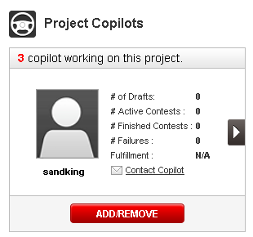

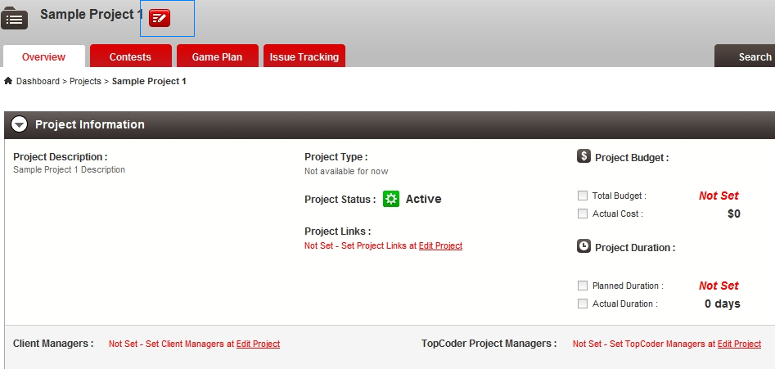

Click the button at the right of the project name to edit project, you need to add managers in edit project. Add manager for the project in edit page. Add for both Client Managers and TopCoder Managers.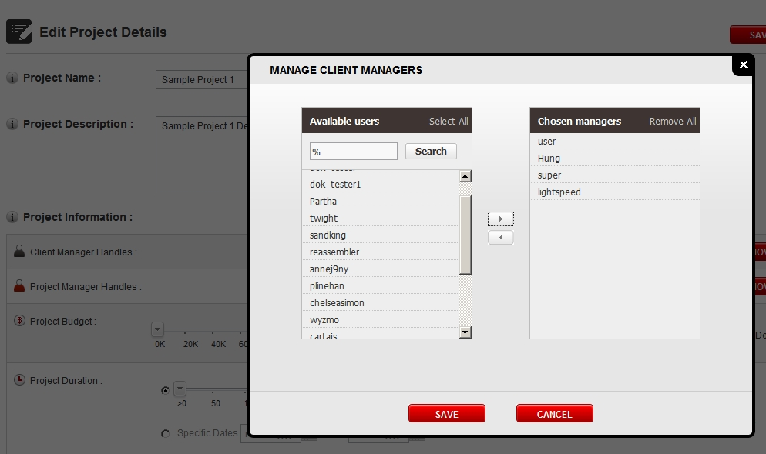

After adding you should see something like this

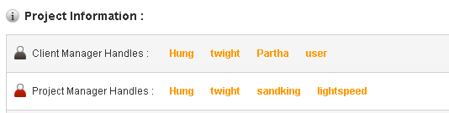

Do the same for another created new project.

Then go to the https://cockpit.cloud.topcoder.com/direct/milestone/projectMilestone to insert some test project milestones.

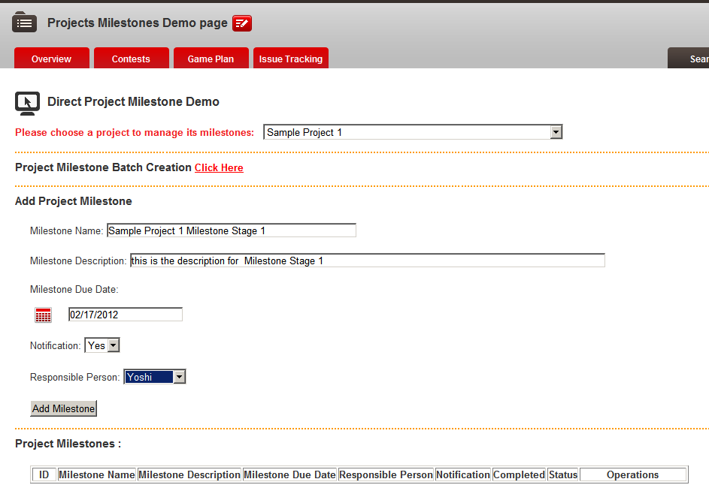

Click Add Milestone

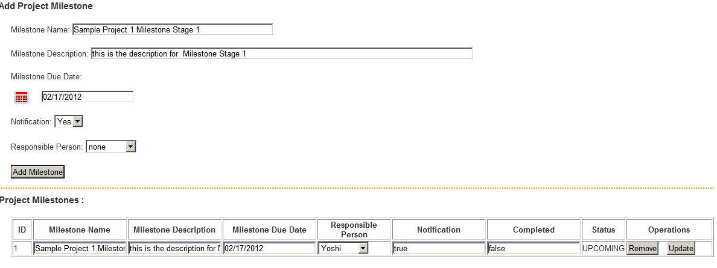

You can see the milestone is added. Edit the added milestone by edit the table contents and click update. For example, set the completed from ‘false’ to ‘true’

Continue to add several project milestones to test remove

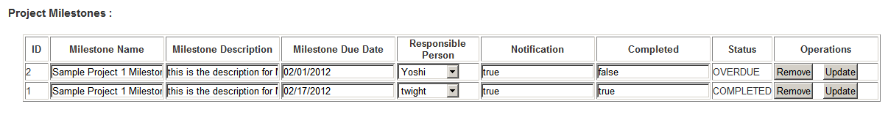

Click the remove button to remove the milestone

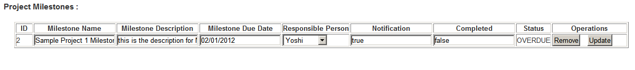

Click the link to test project milestone batch creation



Fill the milestone data for 3 project milestones at once and click “Add All Milestones” to add the 3 milestones at once.

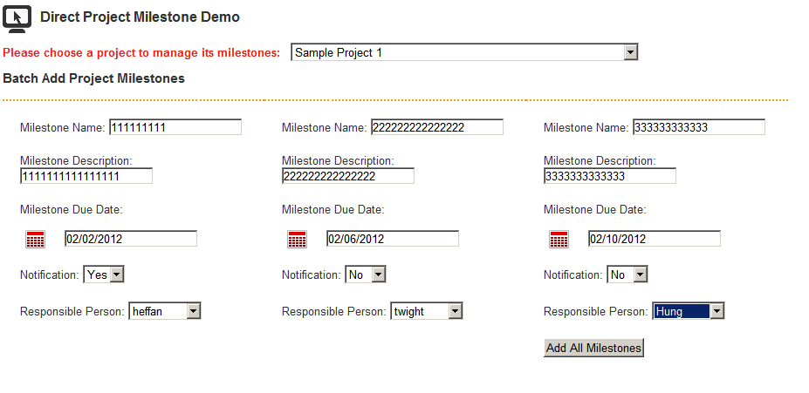

It will redirect to the result page to see added milestones

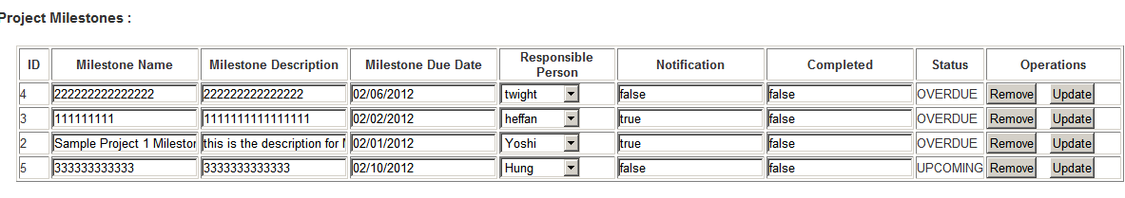

When there are multiple project milestones listed, there is a Delete All Milestones button

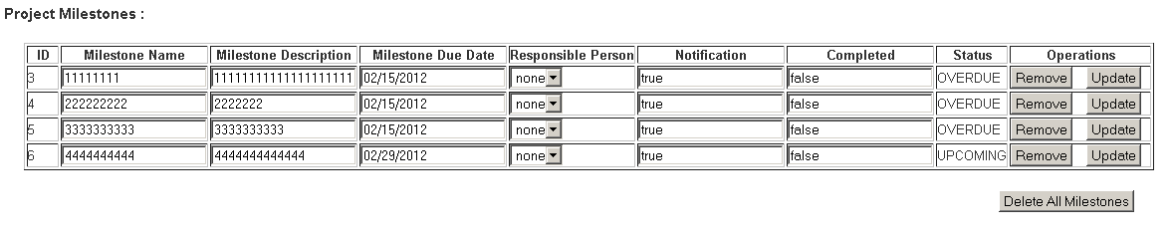

You can click it to delete the entire milestones at one time in the page

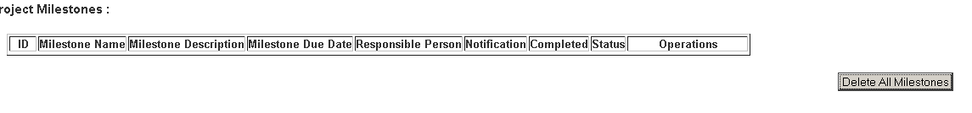

Resource Contact List

Name | Resource Email
TCSASSEMBER

